Special Sites

# Pet Website - .NET Framework v4.8

### How to use

1. The URL will contain a “q” querystring parameter which will contain the email of the Agent

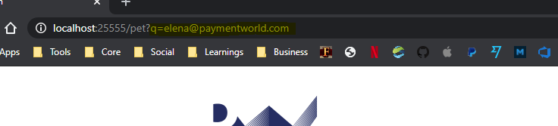

1. The list of Agents and their information is located in the web.config

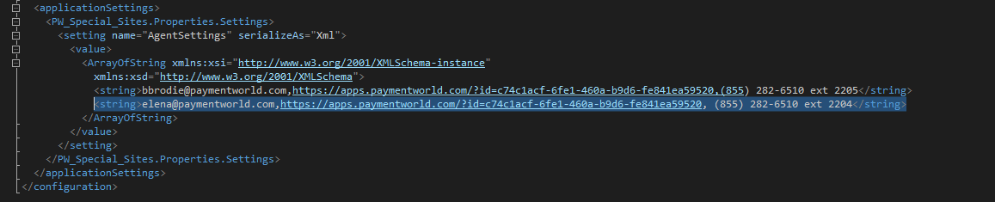

*Note: You can add as much as many agents you like as long as you follow the* ***comma*** *separated information*

***Ex. <string>[Email], [Hosted Agents App Link], [PhoneNumber]</string>***